DFSC 4317 Information Security
Assignment 1
DUE: 01/27 12:15 pm
Instructor: Dr. Cihan Varol, cvarol@shsu.edu
TA: Erasmus Mfodwo, exm251@shsu.edu
40 Points in Total
Name: Zachary Ouzts
Question 1 (8 points): Briefly describe the CIA Triad. Be sure to include a discussion on the topic of its extension to five objectives. For each objective, please provide an example.
Answer: The CIA Triad is a fundamental model of computer security that focuses on protecting information system assets through Confidentiality, Integrity, and Availability.
Confidentiality ensures that information is not disclosed to unauthorized individuals
Examples: Preventing unauthorized users from reading sensitive data
Integrity ensures that the information is accurate and has not been altered or corrupted
Examples: Detecting unauthorized modification of stored data.
Availability ensures that systems and data are accessible to authorized users when needed
Examples: Protecting systems from denial-of-service conditions that make them unavailable
The CIA is Extended by adding Authentication and Accountability
Authentication: Verifies the identity of the user or system
Example: A system confirming a user’s identity before granting access
Accountability : Ensures that actions taken within a system can be traced back to a specific user or process
Example: System logs recording which authenticated users accessed or modified the file
Question 2 (4 points): What is the formula to calculate the number of keys needed to support a symmetric system? If 6 users need to use secret keys to transmit data (symmetric system), how many keys are needed.
Answer: In a Symmetric Encryption System, each pair of users must share a unique secret key. The formula used to calculate the number of keys required is:
$$Number of Keys= \frac{n(n-1)}{2}$$
Where ( n ) is the number of users.
If 6 users need to use secret keys to transmit data :
$$Number of Keys= \frac{6 (6-1)}{2}= \frac{6 (5)}{2}= \frac{30}{2}= 15 Secret Keys$$
A Symmetric system with 6 users requires 15 Secret Keys
Question 3 (8 points): What advantages does SALTING add to the password storage mechanism? Provide the answers given in the class to get credit!
Answer: SALTING improves the security of password storage by adding a random value to a password before it is hashed. This prevents identical passwords from producing the same hash, even across different users. Salting also reduces the effectiveness of dictionary and precomputed hash attacks because attackers cannot reuse previously generated hash values. Overall, salting makes password-cracking attempts significantly more difficult
Example: Two users with the same password have different stored hash values when different salts are applied
Question 4 (5 Points) (Please skip this one if you already installed Kali Linux to your system) (Already Downloaded)
Install Kali Linux to your system via using one of the options shown below. Once you complete the installation, open the terminal (command line) and execute the “date” command to show the current date/time. Attach your screenshot as your answer.
Initial Step: Download Kali Linux and VMware workstation.
Installation Help Video: https://myshsu-my.sharepoint.com/:v:/g/personal/axa184_shsu_edu/ER-0v9EB319Cm_XPF8ao6lQBhEFCEwyp2Bh-9dyvUIKcWQ

Question 5 (15 Points) – Password cracking
Exercise 1.
A suspicious zip file named secretdocument.zip was found in the dark web due to a remote workstation breach at 1300 Smither Drive republic apartment 1010105. The file is encrypted and believed to contain social security number and a vault passcode. As a cyber security professional with specialization in encryption and decryption, you are tasked with cracking the password of this file to reveal its content. Hint: Use fcrackzip with brute forcing mode.
In your submission make sure you accomplish the same result and submit your output with a proof that it is coming from your device (i.e. timestamps, userIDs, screenshots reflecting your names, etc)
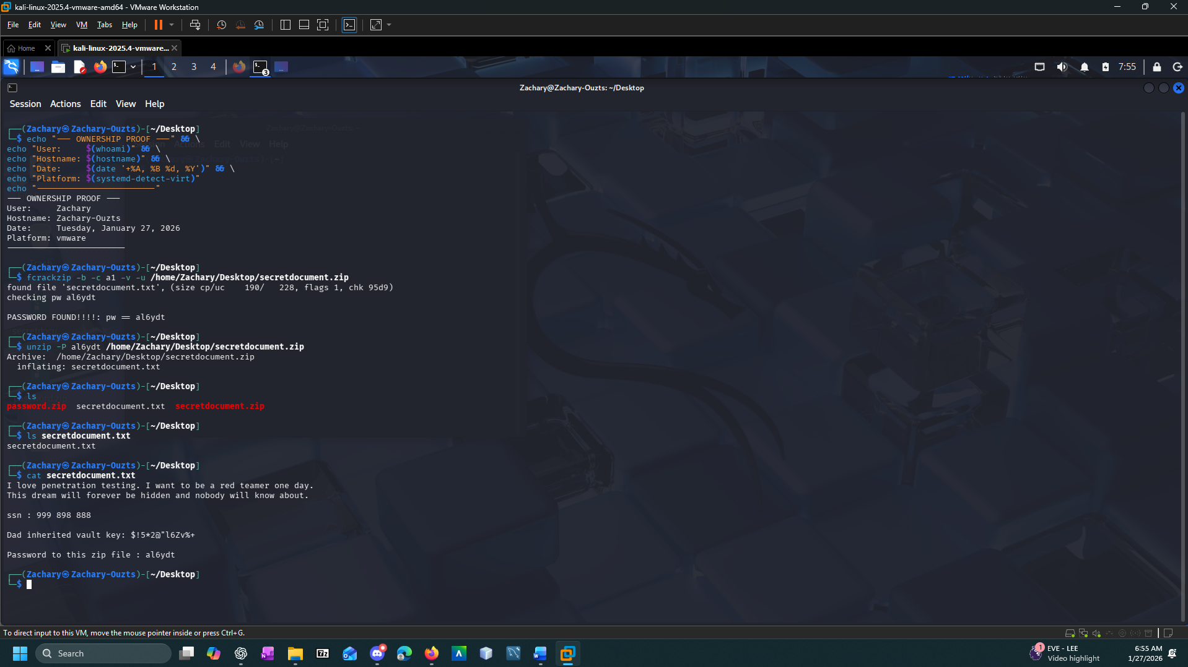
Screenshot of final output is shown below.
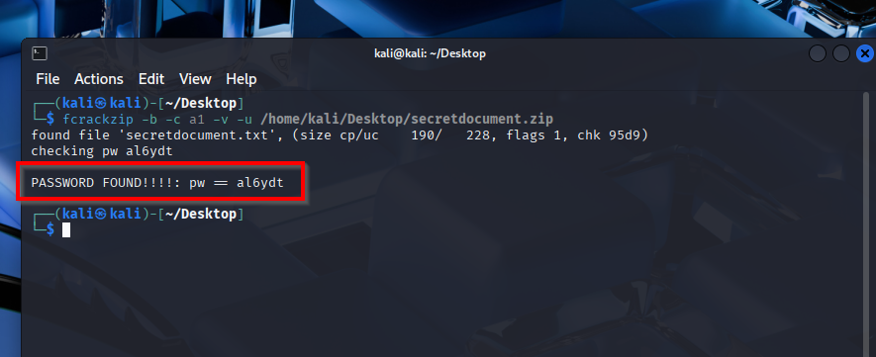

Exercise 2
During the investigation, a forensic sweep of publicly exposed files became available using advanced Google Dorking techniques. Specifically, investigators uncovered a ZIP archive named Password.zip hosted on a suspicious domain and they downloaded it, but the file appeared to be encrypted and inaccessible. Initial brute force attempts were made to crack the file, but they were not successful. Investigators suspect the file might be connected to secretdocument.zip. As decryption expert, your job is to use dictionary attack method to crack the file and find out whether this file has any connection with the secretdocument.zip. In your submission make sure you use your own words to answer the question and attach a screenshot with a proof that it is coming from your device (i.e. timestamps, userIDs, screenshots reflecting your names, etc)
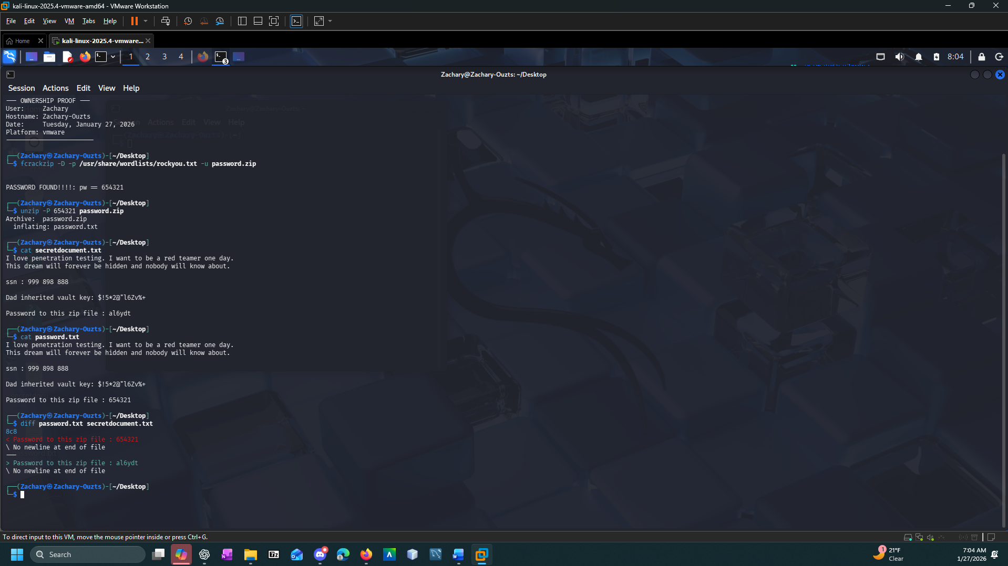

Screenshot of final output is shown below.
unzip -P al6ydt /home/kali/Desktop/secretdocument.zip
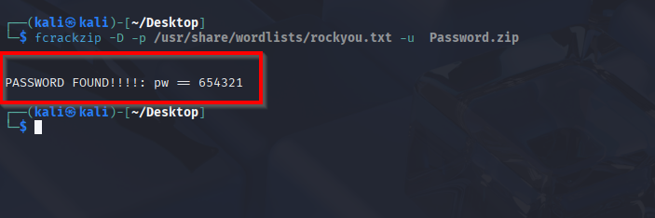
The method described in this title is for educational purposes only and no liability is accepted for abuse.

Appendix
Question 5. Exercise 1
Cracking a ZIP Password with fcrackzip using Brute-Force mode
Step 1: Prepare the Environment
- Boot into Kali Linux.
- Open a terminal window.
- Ensure the ZIP file (secretdocument.zip) is downloaded from blackboard and located in a known directory on your workstation, e.g. /home/kali/Desktop/secretdocument.zip

Step 2: Understand the Attack Method
- You’re using brute-force mode, which generates, and tests password combinations based on a character set and length.
- In this case, the character set is lowercase letters (), and the password length is inferred by default.

Step 3: Run the fcrackzip Command
Use the following command: fcrackzip -b -c a1 -v -u /home/kali/Desktop/secretdocument.zip
Explanation of Flags:
- -b → Brute-force mode
- -c a → Use lowercase letters only
- -v → Verbose output (shows progress)
- -u → Only show the correct password when found
- The ZIP file path is passed directly.

Step 4: Monitor the Output
- fcrackzip will begin testing combinations.
- Once the correct password is found, it will display:
Step 5: Extract the ZIP File
- Now that you have the password (al6ydt), unzip the file with this command (unzip -P al6ydt /home/kali/Desktop/secretdocument.zip) or unzip through the GUI.

Question 5. Exercise 2
Cracking Password.zip Using Dictionary Attack
Step 1: Locate the ZIP File
- Ensure the target file Password.zip is downloaded from blackboard and saved in an accessible directory on your workstation, such as /home/kali/Desktop/Password.zip

Step 2: Prepare the Wordlist
- Kali Linux includes the popular rockyou.txt wordlist, but it's compressed by default. You need to extract it using the command: sudo gunzip /usr/share/wordlists/rockyou.txt.gz
- After extraction, the usable wordlist will be:/usr/share/wordlists/rockyou.txt

Step 3: Run fcrackzip with Dictionary Mode
- Use the following command to launch the dictionary attack: fcrackzip -u -D -p /usr/share/wordlists/rockyou.txt Password.zip

Step 4: Monitor the Output
- fcrackzip will test each password from the wordlist. When it finds the correct one, it will display something like:

Step 5: Extract the ZIP File
- Now that you know the password (654321), extract the contents
Step 6: Analyze the content
Compare the contents of Password.zip with secretdocument.zip

